How to Create and Reset SA Password?

Article Source:

http://recoverlostpassword.com/article/reset-sa-password.html

What is SA?
SA (abbreviation for "System Administrator") refers to the person who maintains and operates Microsoft SQL Server. When you install Microsoft SQL Server Desktop Engine, the installation uses SQL Authentication by default. In addition, the default user name in these cases is sa, and the default password is blank.

How to Secure SQL Server database with SA password?
To make your SQL Server database secured, you are requested to set SA password at the very first time. It is extremely easy to create a SQL Server password as follow:
- Open the SQL Server Management Studio Program from the Start menu bar.
- Hit “SQL Server”, and right-click “security folder”>-“New”>-“Login”.
- Enter the name you like and select “SQL Server Authentication”, and then type a password.
- It is recommend to select “enforcing password policy” when you are requested to select the password policy.
- Click “OK” to finish the creation of the new SA password.
How to Reset SA password?
I frequently find that many users are confused about resetting SA password when I browse SQL forums and communities. In fact, it is very easy to crack SA password with SQL Password Cracker which I experienced for a long time. How to operate it? Just follow me.

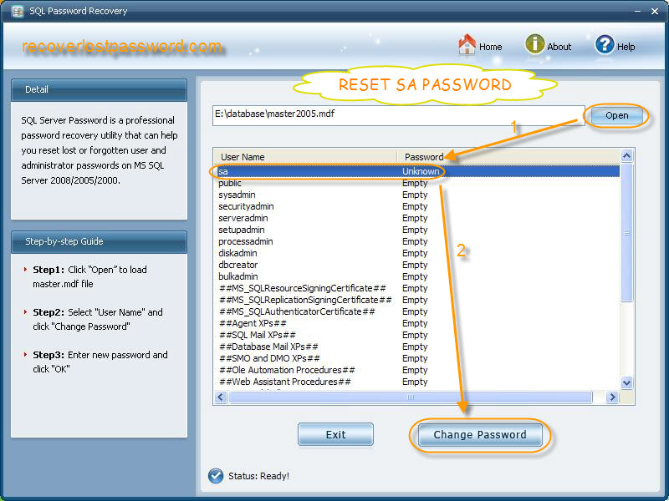

Step 1: Simply download sa password Cracker Tool , and setup and run it. Don’t worry; you don’t need to install MS SQL Server at all. Just load master .mdf file by clicking on “open” and select the files on your PC.

Step 2: All the user names and password of your SQL Server are listed respectively. You need to highlight “sa” and hit “change password.

Step 3: Then a case pops up. What you need to do is to enter your new password and confirm it.

Done! You have finished resetting sa password just with 3 steps.

